Migrating data SVN to AWS Code commit

* First, I have created one EC2 instance to install SVN server.

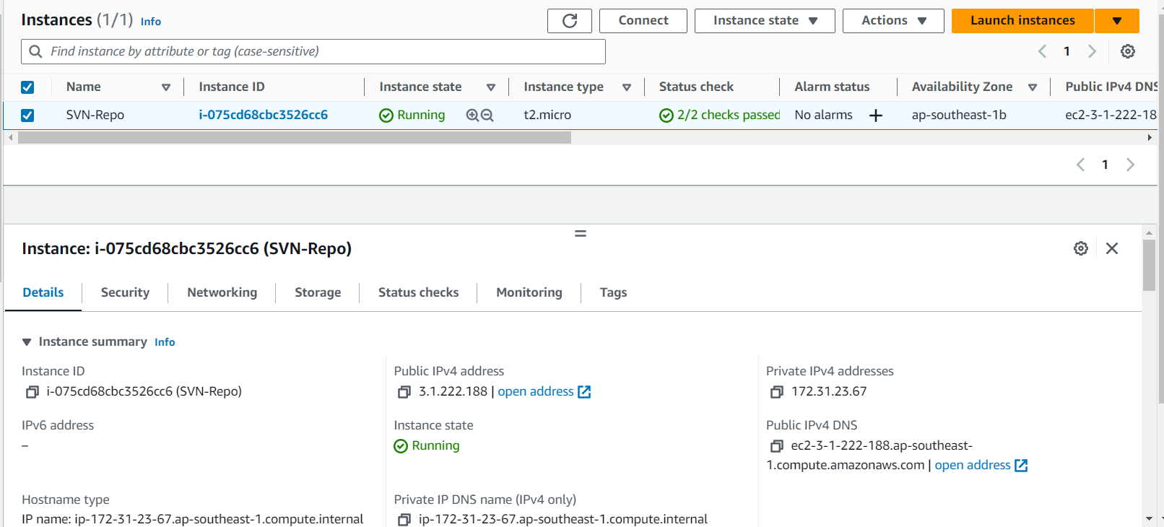

**Step 1:**

**Install SVN and Apache :**

SVN & Apache (http) package are available in the default package repositories of RHEL 8 and Rocky Linux 8.

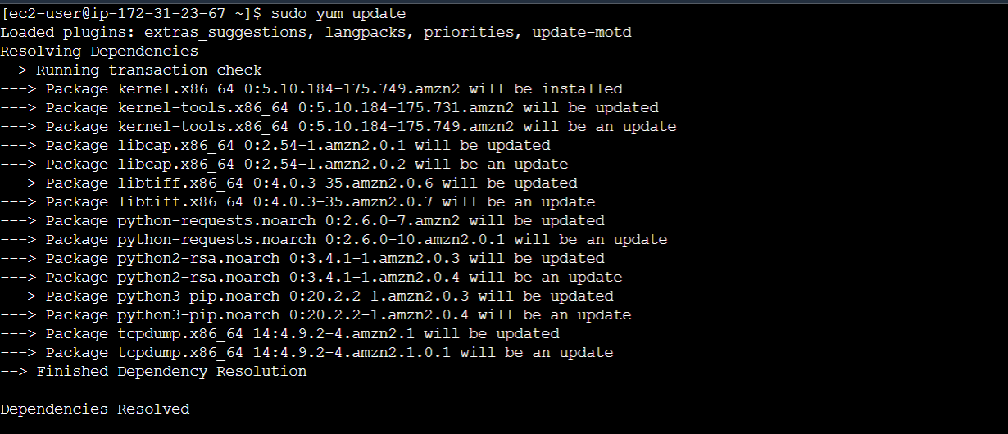

Run following dnf command to install required packages,

🡪 sudo yum install httpd subversion mod_dav_svn

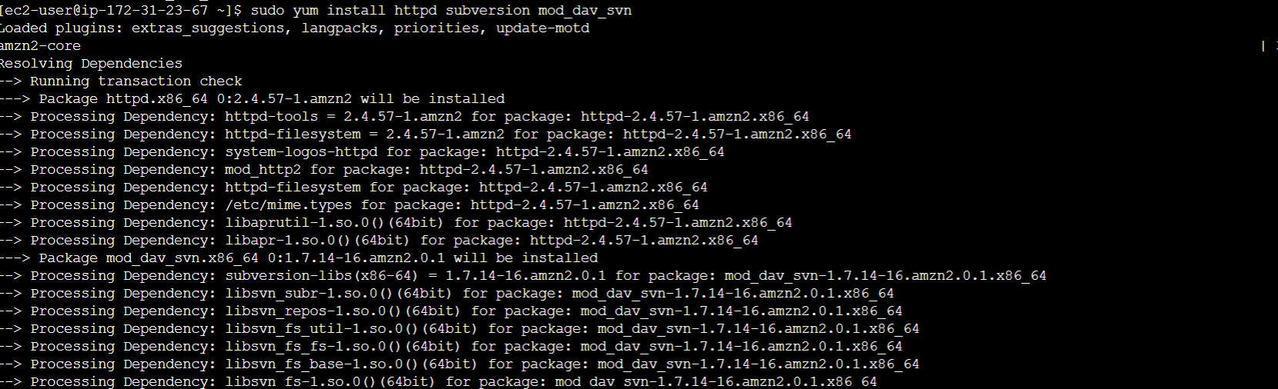

**Step 2 : Edit Configuration File of Apache Subversion**

Create a file ‘/etc/httpd/conf.d/subversion.conf’ and add the following lines to it.

$ sudo vi /etc/httpd/conf.d/subversion.conf

<Location /svn>

DAV svn

SVNParentPath /var/www/svn/

AuthType Basic

AuthName "SVN Repository"

AuthUserFile /etc/svn/svn-auth-accounts

Require valid-user

</Location>

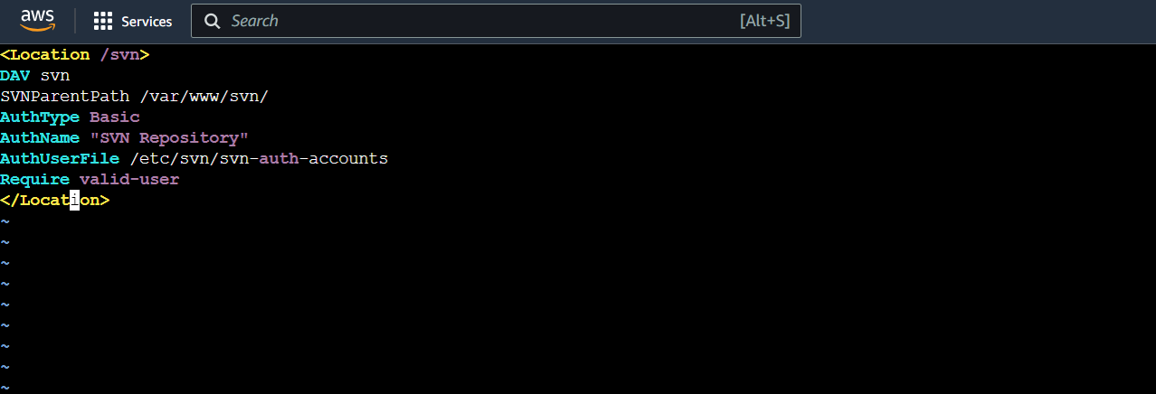

Above settings will allow only the authenticated users to use SVN repository.

**Step 3: Create SVN Users via htpasswd command**

Run the beneath command to create user for SVN via htpasswd command.

$ sudo htpasswd -cm /etc/svn-auth-accounts linuxtechi

New password:

Re-type new password:

Adding password for user linuxtechi

$

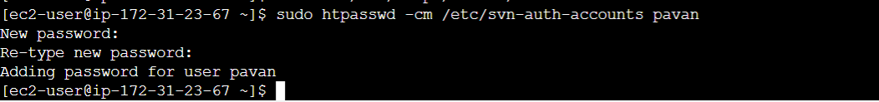

In the above htpasswd command we have used ‘-c’ & ‘-m’ options. -c is used to create the password file (/etc/svn-auth-accounts) and -m used to create MD5 encryption password for the user. To create second user remove the ‘-c’ from the above command otherwise it will overwrite existing file.

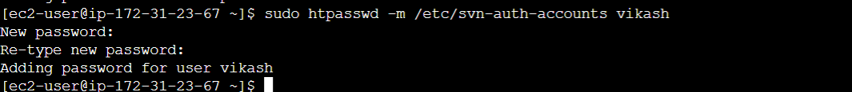

**Step 4: Create SVN Repository**

Run following commands one after another to create your first svn repository and to set the required permissions,

$ sudo mkdir /var/www/svn

$ cd /var/www/svn/

$ sudo svnadmin create my-repo

$ sudo chown apache.apache my-repo/

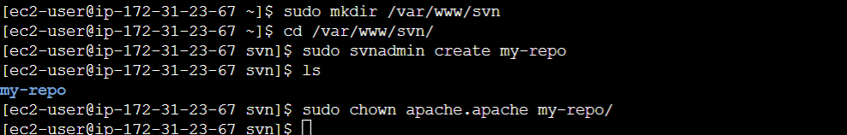

**Step 5:** **Start and Enable Apache Service**

Run the beneath systemctl commands to start and enable apache web server’s service.



**Step 6: Access SVN Repo from Web Browser**

Type the following URL in your web server.

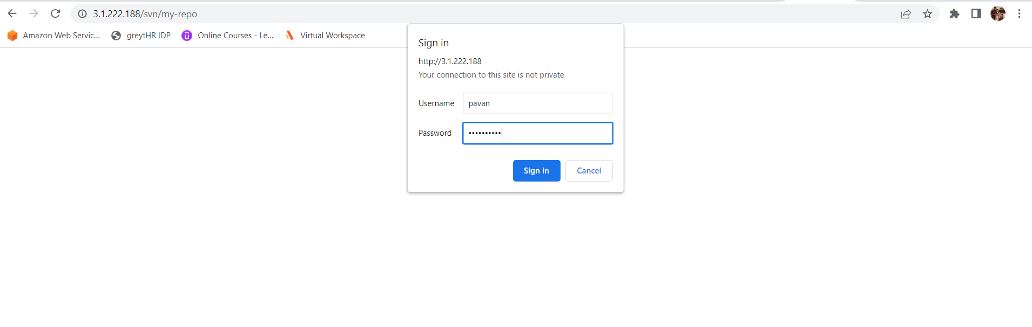

http://<SVN-System-IP>/svn/repo

In the browser just replace ip address with your SVN Server’s IP

<http://3.1.222.188/svn/my-repo>

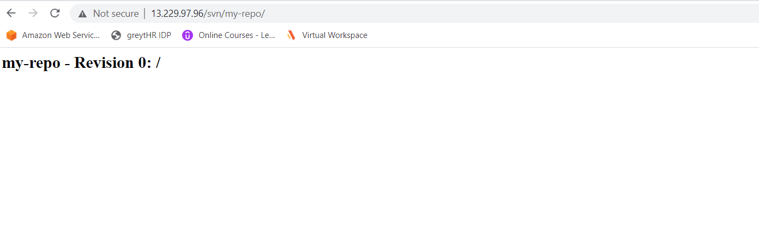

**Step 7:Disable anonymous access on SVN Repository**

Edit the file – /var/www/svn/repo/conf/svnserve.conf, add the below two lines

## Disable Anonymous Access

anon-access = none

## Enable Access control

authz-db = authz

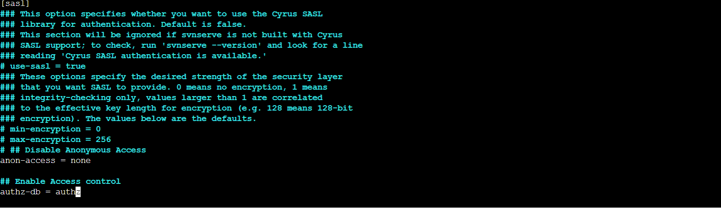

**Step 8:** **Import Project Directory’s Content to SVN repository**

Lets create our first sample project directory and its file.

$ mkdir devops

$ cd devops/

$ touch testfile_1 ; touch testfile_2

$

Now use SVN command to import ‘devops’ project to the repo. As we have created sample ‘devops’ project on the svn server itself. So run following svn command,

sudo svn import -m "First SVN Repo" devops <file:///var/www/svn/my-repo/devops>



Now Check from the Browser

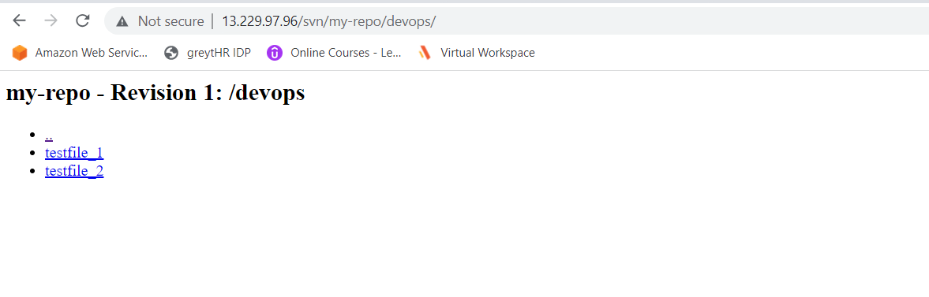

If we want to see the list of files in our repository on console level we can use below command

$ svn list <http://13.229.97.96/svn/my-repo/devops>

for the repo access we need to give user name and passwd

Next, I have to import SVN format data into my-repo

I have cloned SVN format code into SVN EC2 server and saved in devops path, which we have created earlier

$ git clone <https://github.com/WPPlugins/formategory.git>

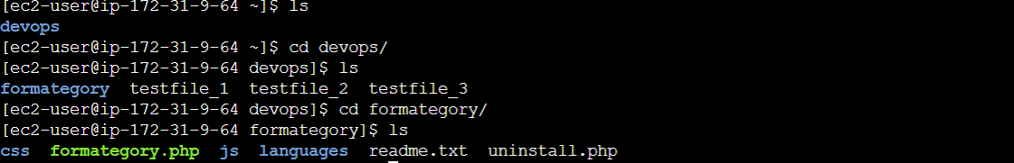

$ svn list http://3.109.55.140/svn/my-repo/devops

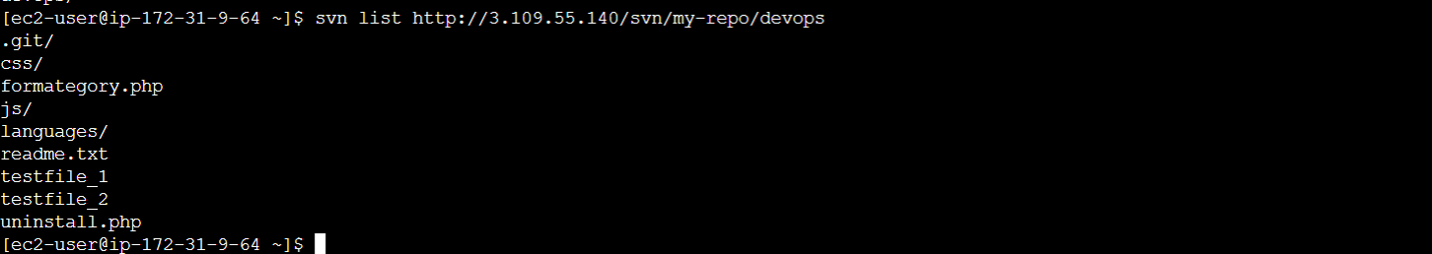

**Step 9:** **Check out the project**

In my case, I want to checkout the devops project on my windows laptop using SVN command. So to perform checkout operations, please make your system has subversion package installed, if not then use “sudo yum install -y subversion“ command to install required package.

Sudo yum install -y subversion

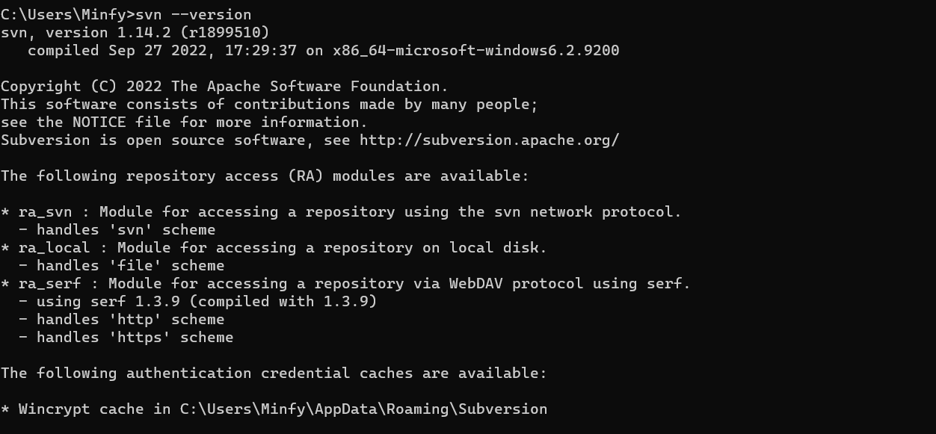

$ mkdir svn_data

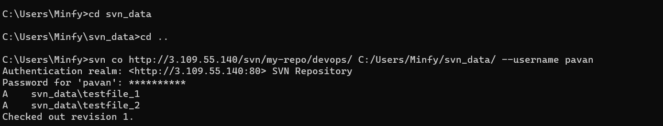

$ svn co http://192.168.1.180/svn/my-repo/devops/ C:\Users\Minfy\Desktop\SVN-Repo\SVN-data --username pavan

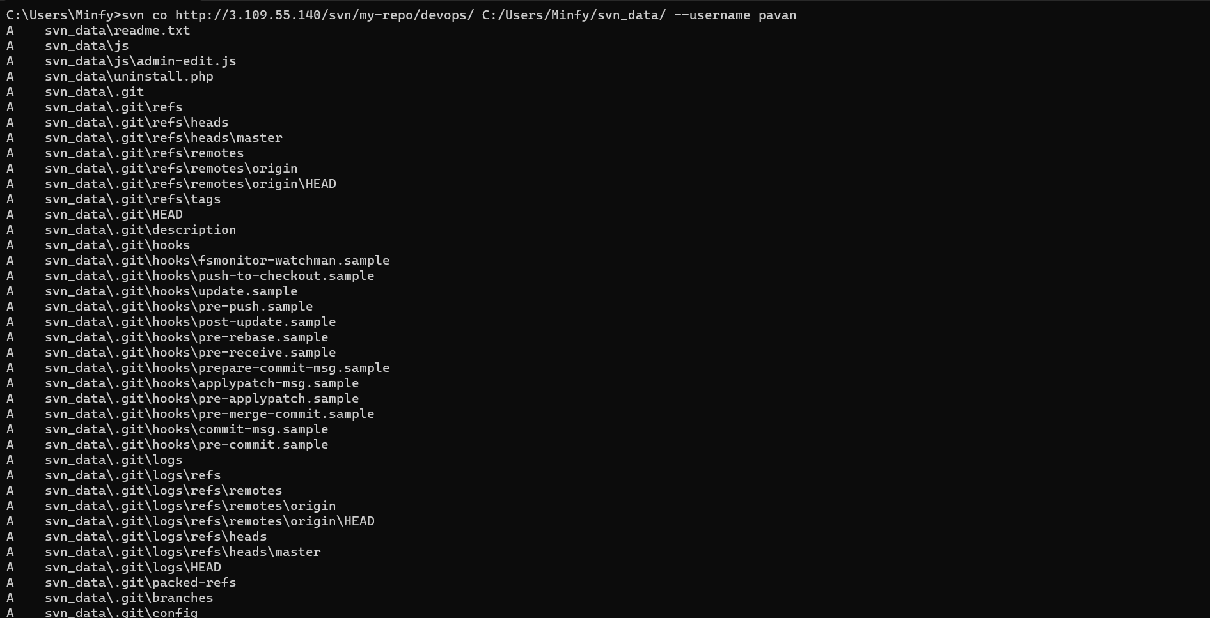

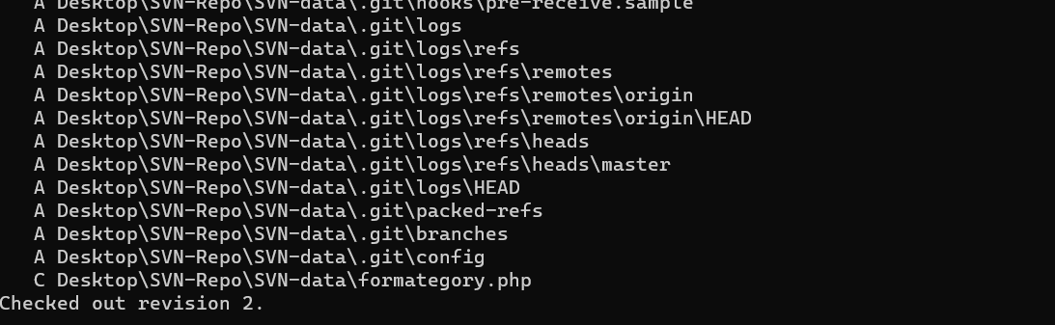

Now we can see the SVN data into local folder

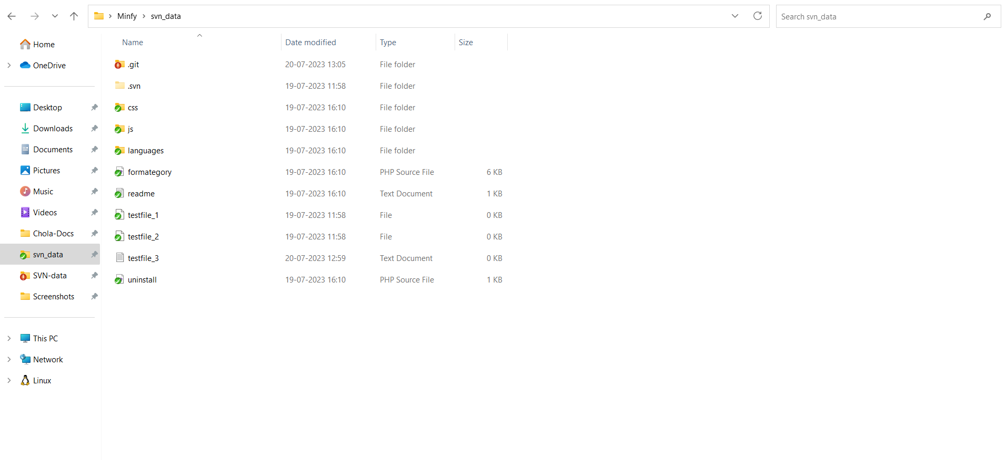

**Step 10:** **Data copying local machine to AWS code commit**

* For that I have created one repo in AWS Code commit in AWS console

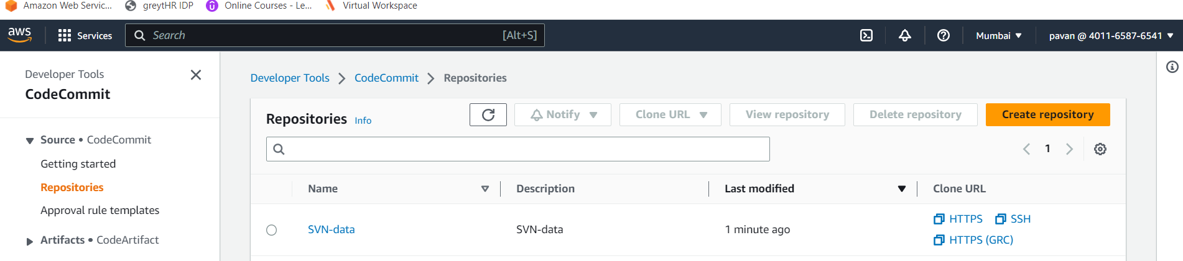

* Next I have cloned repo into local
* We have already SVN format data in folder
* Through git bash I have migrated data local to code commit by using below command.
* git init
* git add .
* git commit -m “files added”
* git push

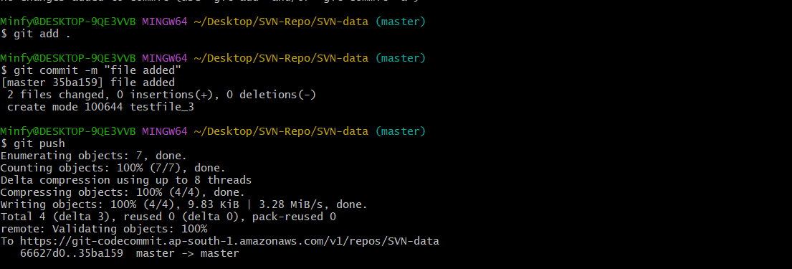

* Finally, the SVN data transferred in to AWS code commit
* Now you can check in AWS code commit repo.

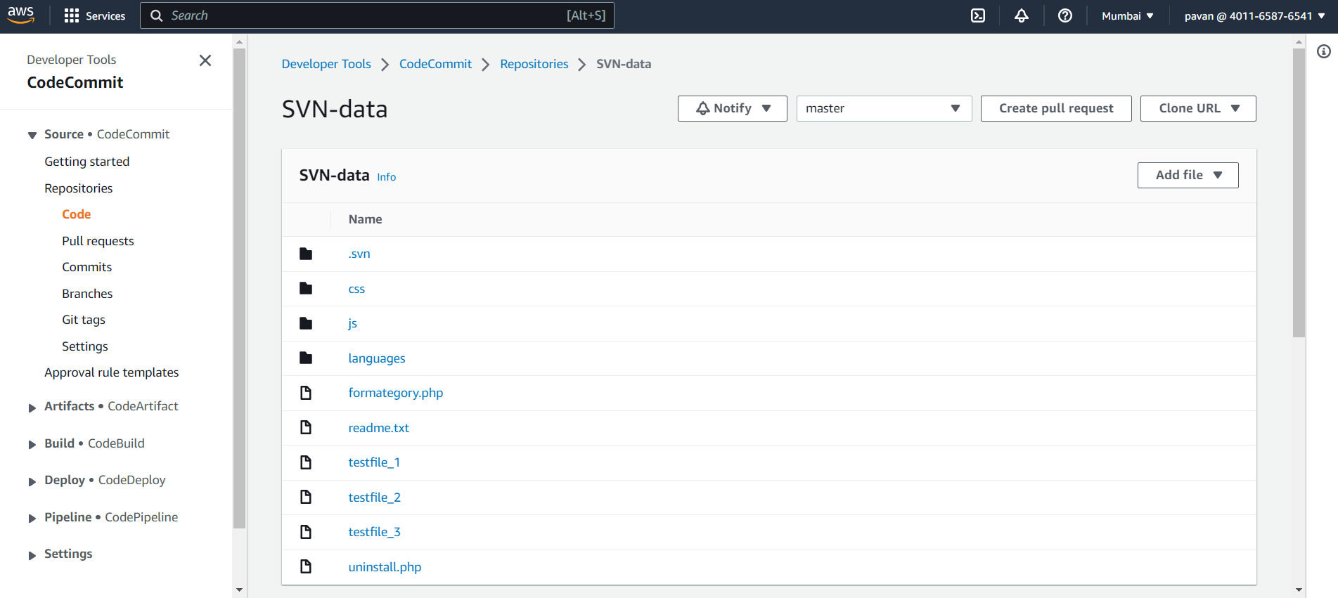

Reference link : https://www.linuxtechi.com/install-apache-subversion-svn-linux/